ANNUAL REPORT-2019-2020

Gram swarajya Samiti Ghoshi

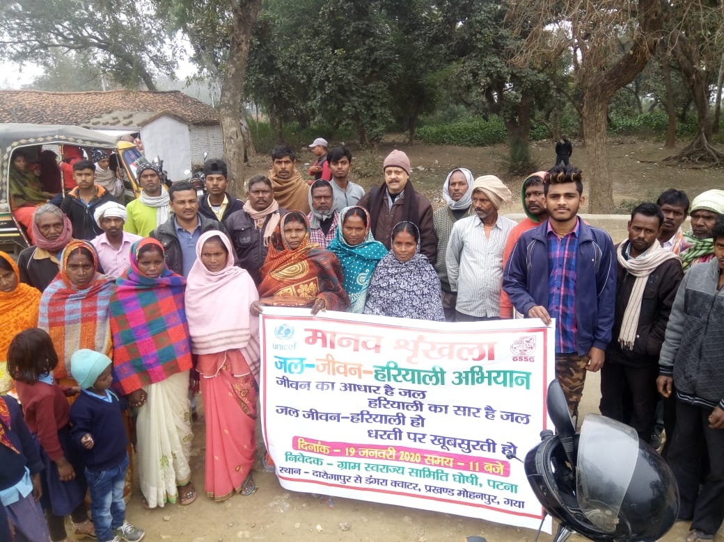

PRESENTED BY
GRAM SWARAJYA SAMITI, GHOSHI
Regd.Off.- At & PO: Bandhuganj, Dist: Jehanabad (Bihar)
Admin.Off-CC-5,2nd Floor, P.C.Colony, Near Lohiya Nagar Post Office,
Kankerbagh,Patna-800020
Email: gramswarajya710@gmail.com ,Website:www.gssg.org.in, Tel: 0612 – 2366557,
Mob: 9431828306

Key Message from Secretary
It’ gives me immense pleasure to share the annual report on behalf of the organization GSSG, for the financial year 2019-20.This report reflects the activity carried out by the organization with the support of our dedicated employees and workers. It also reflects the impact on societies and community. Effort has been made to understand the development issues and challenges of the target community for their all-round development. GSSG has brought the achievement report based on the minimized of the challenges and past learning.
In the light of community based issues as prioritized by the community, GSSG is more focused on the issues like awareness on COVID-19 pandemic, safe drinking water, sustainable sanitation and hygiene, gender equality,Women &chiialsld rights, focused on jal jeevan Hariyali and green earth clean earth etc.
GSSG always try to engage the all stake holders as MP, MLA, PRIs members, Govt officials, Front line health workers and chairman/wardcousnellors of Municipal Corporation for the redressal of the basic issues of the community to minimize the challenges of the target area by respective role and responsibility for the community. It’s the mandate of GSSG; identify the gaps and challenges implementation of different government scheme at grass root level for the welfare of the deprived group.
We heartily admire and gratified to all the direct and indirect supporting agencies, networks, communities who facilitated enormous backup and support.
The initiative taken during the financial year 2019–20 is presented in this annual report. Governing body of GSSG continues to be grateful to our Networking partners, funding partners, local authorities and importantly the communities both urban and rural mass with whom GSSG involved with.

Ram Shankar Sharma
Secretary

INTRODUCTION
GRAM SWARAJYA SAMITI GHOSHI (GSSG) was incepted in year 1990 by a group of social workers involved in the development activities for the changes of the social status in Bihar The society focused its attention initially on the development of Jehanabad & Arwal district and gradually across the state. We started our activities in the district of Jehanabad which was then witnessing mindless killings by extremist outfits. The organization over a period of time attributed the calmness, bringing harmony and brotherhood in the society.
The given mandate of the newly formed society was to resolve the root cause of violence through Gandhian teaching of truth, non-violence, and Gram Swarajya. In due course of time, the organization expanded its scope and geographical boundaries. The various development program that had has been executed by GSSG is related to strengthening of local self government, water and sanitation, peace and social justice, universalization of education, skill up gradation and micro enterprise creation , self-help group development, responding HIV/AIDS through involving brothel/commercial Sex Workers and their client, Reproductive and child health development, Gender justice, policy and advocacy program, campaign to combat human trafficking, women & child rights, promotion of right to information, complimentary support in implementation of ambitious schemes like MGNREGA, Indira AwasYojna (IAY), Public insurance schemes, Jal Jeevan Hariali etc. The society was incepted in early nineties and formally got registered in year 1993 with Government of Bihar with the objective to respond socio economic challenges that has been manifested in caste and class violence in Bihar. In its more than two decades of Journey as social enterprise executed several development projects that brought changes in lives and livelihood of their targeted population. Many of such interventions had been recognised by international donors and our own government.

In these years, our geographical coverage and dimension of developmental support to needy population has been expanded. The society is focussing its intervention in United Ghoshi Block (Old) of Jehabanad and Patna district. It has also registered impressive presence in Social Sector of Bihar by facilitating organisation of Civil Society Networks like VISWASH (Voluntary Initiative on Sustainable Water Sanitation and Hygiene), FANSA (Fresh Water Action Network of South Asia), BIWA (Bihar WASH Alliance), ATSEC (Action against Trafficking and Sexual Exploitation in women and Children) Bihar Chapter etc. Women and Dalits are focus of its development intervention in these regions, since they are the worst affected group of all burns caused by cast violence, poverty & age old stereo type.
Vision:.To inspire & empower people win poverty, respect human values and preserve nature
Mission: To work with community to end miseries surrounding them and become able to care mother earth.

Core Strength area of the Organisation

Based on rigorous efforts and experiences, organisation has developed some strength area through which running the projects which are given below:

.

Organogram of GSSG

The Major stakeholders of GSSG are:
- Grass root level CBO’s
- Government officials of different departments
- Law Enforcement Personnel
- Judiciaries
- Policy makers (Legislative Assembly and members of Parliament )
- Govt. frontline outreach health service providers.
- Elected representatives of Panchyati Raj Institutions
- Community leaders/Religious leaders.
- Men/Women
- Children
- Youth/Adolescents(Girls and boys)
- Members of Various community level Institutions-SMC, CPC,VHSNC,RKS etc.
- Community People
- National Social Service(NSS) Volunteers
- Nehru Yuva Kendra(NYK) Volunteers
- Tuberculosis Champions
- Family Planning Champions.
Network Membership Of the GSSG
- VISWASH-Bihar(Voluntary initiative for sustainable action on water sanitation and hygiene)
- FANSA (Fresh Water Action Network of South Asia.)
- BVHA( Bihar Voluntary Health Association)
- Member of Jan Swasthya Abhiyan (People’s health Movement)
- Bihar WASH Alliance (Initiated by UNICEF-Bihar)
- Member of Family Planning Alliance( Initiated By Global Health strategies)
- Member of CCHT( Collective Coalition against Human Trafficking)
- Bachpan Bacho Andolan
- ATSEC(Action against Trafficking and Sexual exploitation among women and children)
- Women Power Connect( WPC)
- GSSG coordinating agency of FANSA/VISWASH Bihar Chapter

Organizational Management:
We believe in democratic values which govern our action and decision. The organization has sound governance structure led by highest authority General body. Leadership is given by president elect. Apart from resolving on policy direction, General body approves, long term plan, annual plan, budgetary allocations and previous year annual report and audited statements, presented by the executive committee. The general Body meetings are being held on yearly and if required it can be held more than one approves the Annual times as per GSSG Bye laws.
The Organization has its 11 members Executive committee elected among membership of general body. Secretary leads the Executive Committee. Executive committee is supposed to implement policy resolve of General Body. Executive committee also guides business of the organization. The decision is taken in periodic meetings of governing body. Gender is one of the major concerns of GSSG management and hence about 40 % of the governing board members are female. Besides this, there are other standing committees for the organization :

Position of secretary has been created by the constitution. Secretary is expected to perform multiple roles. His constitutional obligation is to in implementation of its constitutional procedure with due diligence. . The day to day program management and administration is responsibility of the secretary of GSSG. He is assisted by the Program manager and Admin executive with full participation of core team to implement programs as per the laid down instructions of Governing board.
Besides this, there are other standing committees for the organization as mentioned below:
1. GSSG Policy development committee: This is a three members committee. The members are from the governing board. The role of this committee is to develop policies in the organization as per the direction of the governing board of the GSSG to change/amend some of its policies for effective functioning of the organization.
2. GSSG Legal and inquiry committee: This a three members committee comprises of board members of GSSG. The purpose is to see the legal implications and recommends the governing Board with suggestion and corrective measures.
3. GSSG Program Advisory Committee: This committee comprises a good number of subject experts from the development sectors and some expert of the governing body members. The committee members have huge expertise in development field. .this committee sits generally once in a year or as and required. The purpose of the committee is to guide and suggest to from GSSG’s strategic planning, policy advocacy and other need based program planning.
4. GSSG Gender committee: This committee comprises of governing board members especially the female members. The function of the committee is to handle the grievances/Complaints of the female workers/staff to help and developing conducive and congenial environment for working female staff and forward recommendation to governing board for any amendment and action.

Summary of Activity 2019-20
EU Funded & Aga Khan Foundation assisted ULB reform Project, Bihar
Focus: Solid waste management

Capacity Building Training Programme on Waste Management

1. Training of citizen Leader on Solid Waste Management:-

1. Summary of Training:-
- Discussion on mutual relation of Urbanisation & Global Warming
- Discussion on Status of sanitation in India and its impact on life and livilihood of people
- Describe sustainability of sanitation services in terms of behavior, O&M, sanitation financing, Investment, community participation etc.
- Overview of EU Funded & Aga Kahan Promoted SWM Bihar Project
- Disucss roles and responsibilties of different stake holders in Municipal Solid Waste Management area
- Discuss concept of citizen leaders and their roles & responsilbities sustainable and quality sanitation services (mailly mobilsation of community aprticipation,Evaluation of SWM services, feed back, awareness creation, community based micro planning
- Understand Municipal governance system in Bihar
- To apprise the participants on some useful tools of Municipal Solid Waste management i.e. participatory planning, Service level benchmark, Swachata Apps
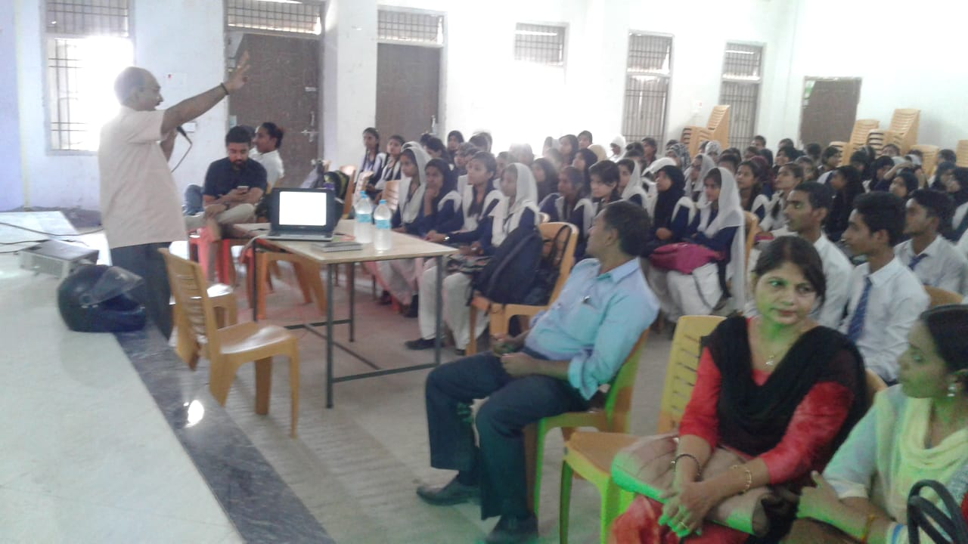
- Discuss solid waste management technologies mainly home composting.
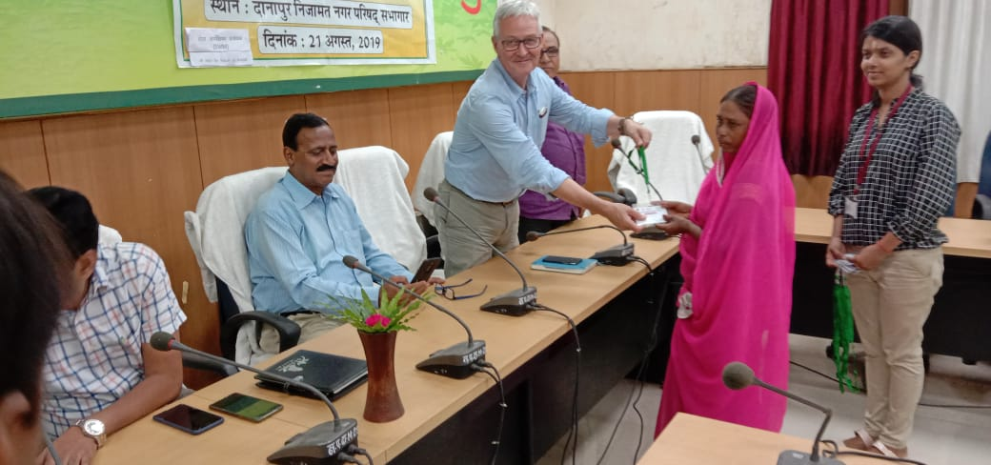
Citizen leader training on SWM at Khagaul NP
Delegate from UK AKF giving certificate to the Citizen Leader

No of Total Training and Outcome: In continuation of the program total 10 citizen leader training has been organized in the three ULB i.e Danapur Nizamat, Phulwarisharif and Khagaul.Total 920 citizen leader has been given training on how to segregate the solid waste at the source level. Promotion of home composting has been the prime objective of the program so that to minimize the waste . Apart from this 17 Temple composting and 8 group composting also promoted. Total 1360 house hold regular practicing home composting.
2. Training with ULB Authorities on Solid Waste Management
The Urban Local Body( ULB) authorities have meeting on the solid waste management and the discussion was based on the following agenda:
- Agenda
- Discussion on scenario of sanitation and solid waste management and related challenges in respective ULB.
- Develop understanding on effectiveness & challenges of municipal governance in area of Solid waste management in Bihar.
- Share concept of Citizen Leaders and resolve on their roles and responsibilities in SWM.
- Discuss some useful tools of Municipal Solid Waste management i.e. participatory planning, Service level benchmark, Swachata Apps
b. Summary of meeting:
- Discussion onhow to make better management for source Segregation:
Resolution:
- Discussion on the role of parvesh mitra and the ward members in context of SWM.
Resolution:
- Describe sustainability of sanitation services in terms of behavior, O&M, sanitation financing, Investment, community participation etc.
- . programOverview of EU Funded & Aga Khan Promoted SWM Bihar Project
- Disucss roles and responsibilties of different stake holders especially the business community in the market area
- Discuss concept of citizen leaders and their roles & responsilbities sustainable and quality sanitation services (mainly mobilsation of community participation,Evaluation of SWM services, feed back, awareness creation, community based micro planning.
- Understand Municipal governance system in Bihar .
- To apprise the participants on some useful tools of Municipal Solid Waste management i.e. participatory planning, Service level benchmark, Swachata Apps
- Discuss solid waste management technologies mainly home composting and also about the role of Parivesh mitra.
VOICES OF ULB OFFICIALS: The ward member of the khagaul said that the awareness among the people is more important that’s why still we are lagging behind. City manager NULM also briefly illustrated about the importance of SWM. He said one should not be centric towards the government only. They have their limitation .Firstly we have to develop our civic sense and awareness campaign is one of the major tool to maximize our reach among the people. Segregation of waste at the source has to be implemented and for this we have to promote door to door visit.
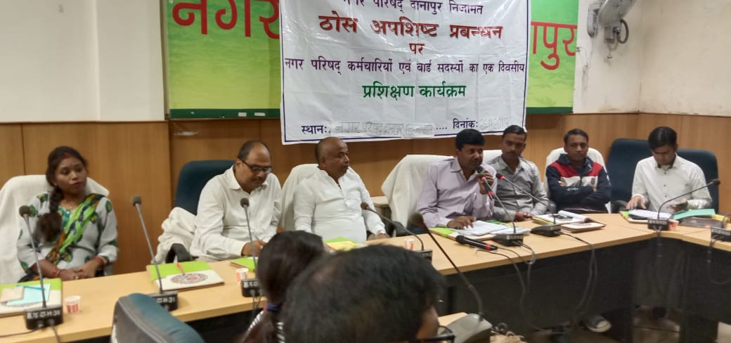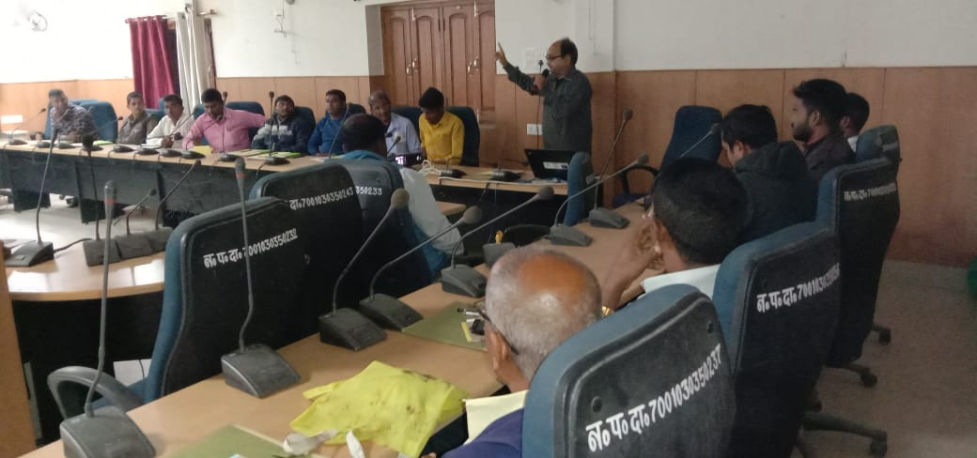
ULB staff training on solid waste management Mr.Deepak kumar (vice president) participated as chief guest of the program.

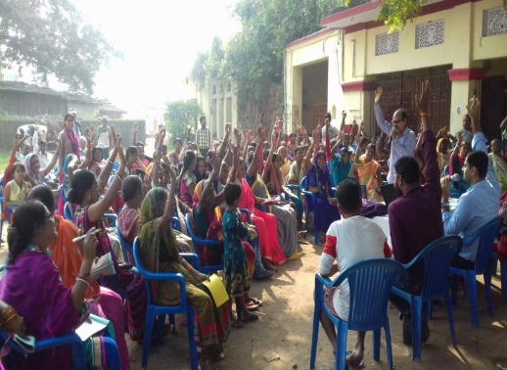
3. Public hearing: Aga Khan Foundation with assistance of EU has been involved with three Nagar Parishads of Patna Districts to assist concerned ULB in area of SWM reform with the implementing partner Gram SwarajyaSamitiGhoshi. The project aimed to assist ULB authorities for accountable, responsive & transparent system of solid waste. Key activities envisaged under the project is as follows: House Hold Survey on SWM practices; Ward Profiling; Identification of citizen leader; volunteers; rag pickers; SHGs & Train/Sensitize them in SWM & streamline them; Assist ULB in ODF activities; Pilot concept of reduce, reuse, recycle municipal solid waste, Home composting, Door to Door collection. The Public hearing is supposed to discuss/Share Municipal Governance focused to SWM.
Public hearing performed in presence of EO khagaul NP
Objective:
- To increase the participation reach in SWM services.
- To increase and improve sense of accountability among service provider.
- To have discussion on problem solving related Questions on SWM.
Outcome: Increase participation of citizens under the Solid waste management due to availability of forum of open discussion. By way of that to excel the SWM program and minimize the grievance of the citizens.
4. Establishment of Mini Segregation Centre: Under the SWM program supported by Aga Khan Foundation and funded by EU one mini segregation centre has been stablished in Khagaul Nagar Parisad.SHG Mahilla group has been involved in the door to door collection of wet and dry waste. Composting has been started at the mini segregation centre and is a good source of reducing the waste at the source level and about 2 ton of solid waste has been collected and disposed of regularly on daily basis.
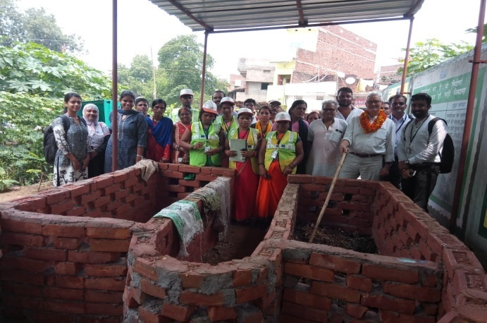
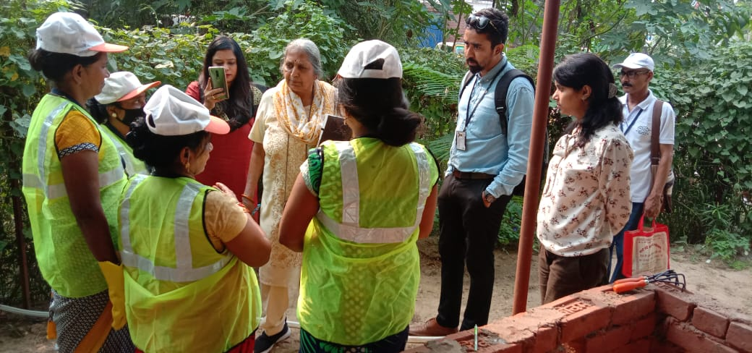
AKF UK and Delhi team visited the functional mini segregation centre of GSSG at Khagaul NP
Progress Statistics:
Citizen Leader Cumulative figure:
Citizen Leader Cumulative Figure
ULB | Month February 2019 | Jan-20
Danapur Nizamat | 168 | 560
Phulwarisharif | 70 | 366
Khagaul | 525 | 683

Home compost:
Home compost Cumulative figure
ULB | Month February 2019 | Jan-20
Danapur Nizamat | 16 | 454
Phulwarisharif | 16 | 246
Khagaul | 44 | 660

4.Jal-JeevanHariyali Mission

The govt.of Bihar has taken up a most relevant and earth saving step to ensure safe environment and save life of living beings on earth. To make people understand the value, a Human chain formed in whole Bihar for creating a very positive environment in the people.
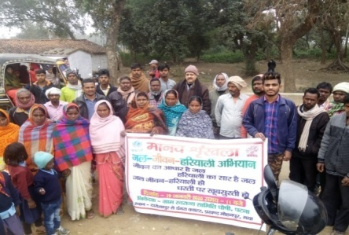

Objective: To make people aware and understand the mission of Jal Jeevan Hariyali, and hidden facts of to persevere the nature and environment.
The govt. of Bihar has taken Jal jeevan Hariyali to create greenery in whole Bihar with planting around 2.5 crore plant to create 33% greenery on land which is essential on earth. Under the mission, well planned to renovate wells, cleaning ponds, reveres, pyne, ahar and develop rainwater harvesting technology on govt. buildings and motivate mass to adopt it to store rain water and re-use.
The govt. has decided to develop check dam to restore the rainwater and focusing on ground water recharging to ensure utility of available water. There is need to aware farmers not to give fire to the straw which damages environment and increases temperature at large. We must break the religious myths and wrong practices such as giving fire to woods on Holikadahan, using crackers on festival deepawali, during marriage and reducing, recycling,storage, transporting and disposal of solid as well as liquid wastes in adequate place and proper Waste disposal management must be taken in to account.
Govt. should also focus on research for alternative techniques for Building, road, bridge construction to reduce the dust and smock which damages the environment and atmosphere.
Though govt. has started focused work on promotion of toilet in every household to reduce soil and environment pollution,but simply construction of toilet is not enough. There is a need to bring change in deep rooted behavior of the community and make them realize the consequences of open defecation on family as well as society.
Well govt. has started working for promotion of renewable energy such as E- rickshaw and CNG driven vehicles.The women and youth should be given orientation on WASH and impact of poor environment on their life.
Mr. Arun kumar,Prog.coordinator,Rapid Pro and Mr. Rajesh Paswan, Block Coordinator, Mohanpur had a meeting at Dangra on 18th January2020 and motivated community leaders, women and youths to join hands in the govt. mission and support in forming Manav shrinkhla(मानवशृंखला )for the noble cause.
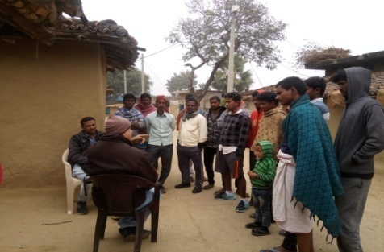
GSSG team interacted with community on Jal Jeevan Hariyali
300 women, men, girls and youths participated in the Manav Shrinkhla under the banner of GSSG for streamline the Jal Jeevan Hariyali mission.
Out come :- awareness has been created and people are keen for plantation, saving energy and keep the environment .They are aware about rain water harvesting and recharge ground water.
In continuation of this program GSSG organized two workshop at different places.
1.As decided by the govt.of Bihar to organize JJHM activities on every first Tuesday of the month, Mr. Arun kumar,Programme Coordinator,GSSG actively participated in orientation of PRI and officials on JJHM at TRYSEM Training building Belaganj Gaya and to make people to understand the value, and focused on 11 components such as identify water reservoirs- Pond, River, Paiyeen and free them from illegal encroachment, Renovation of water reservoirs- Pond, River, Paiyeen, Identify public wells and renovation, Development of soak pits near wells and Hand pumps, Development of new check dams, reservoirs near small revers, lanes as well as in hilly areas, creation of new reservoirs and deflecting the surplus water from river to the area where there is a shortage of water facilities, development of rain water harvesting system on roofs, Development of Nursery and intensive plantation, Development of new technology as well as alternative cropping pattern for development of Biological fertilizer and Drip irrigation technology, Encourage utility of Solar energy and saving energy as well and awareness of general mass on Jal Jeevan Hariyali.

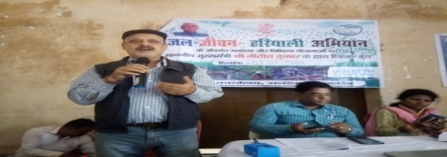
Organization’s officials Addressing the local community on Jal Jeevan Hariyali mission
During the event Mr. Sanjeev Kumar,Block Development Officer,Belaganj, focused on Jal Jeevan Hariyali and shared that honorable chief minister, Bihar has launched Jal Jeevan abhiyan in mission mode and directed all the officials to take up action activities on each level such as Panchayat, Block, Sub Divisional and District level. He further shared that saving earth means saving living beings on earth. Once the thing goes beyond control, it would be late enough to restrict the pathetic condition of the mass on earth.
Since, Energy is the topic of this event today; our focus must be on saving energy and brining solar energy in use for meeting our needs. He further requested media persons to come forward and share message within community for energy saving and using renewable alternatives underJalJeevanHariyali.
Mr. Madhu Kumar, Circle Officer, Belaganj addressed the participants and shred that growth of energy consumption is a worldwide proven indicator and has witnessed high growth of energy consumption in Bihar. JalJeevanHariyali is one of the burning issues on the glob and govt. of Bihar has given focus in mission mode. All the components has to be given priority in our program .Well, Energy as topic of first meeting, we must save energy for future utilization. We should stop misuse of electricity. In production centre, we should use solar energy and save electricity. Solar energy System should be used in all the govt. building to minimize the use of electricity. All the dept. should take initiative to run the facility at the top priority. Some of the PRI as well as ward members also addressed the participant and focused on the need of saving earth.
Ms. Puspakumari,Program.Officer, MGNREGA and focused on the usage of Solar energy and minimizing the misuse of energy.
Seminar-2 on JalJeevanHariyali: Seminar on JalJeevanHariyali has been organized in the Ganga Devi Mahila College,Patna at the conference hall on 3rd March 2020. GSSG has invited as the chief guest and to host the program .GSSG program manager addressed the session and gave brief lecture on JalJeevanHariyali.He also stated that the JalJeevanHariyali is the flagship program of the state and it’s also the responsibility of the students, youth to participate actively in the mission. The objective behind this was to protect the environment, save and recharge ground water and save the earth from the natural crisis. Principal, lecturers and the students participated actively. Painting completion was also organized and Students participated actively on this event.

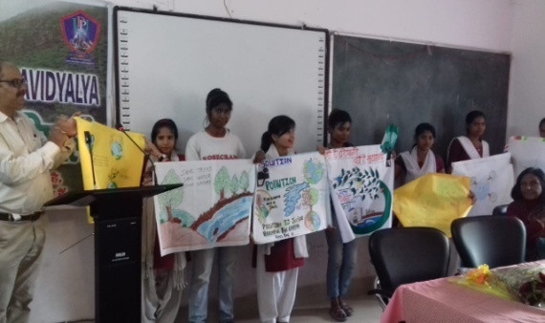
(Program Manager GSSG addressing the session on Jal jeevan Hariyali at Ganga devi Mahila College)

5.Piloting ICT based Public feedback system-Rapid Pro at Gaya District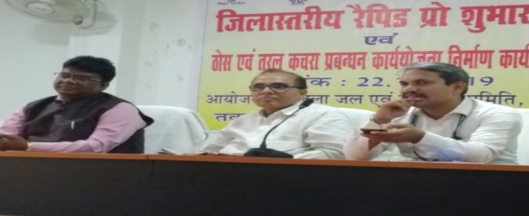
( Mr. Sisir Choudhary, DDC Gaya, Mr. Rajeev Kumar, UNICEF, Mr. Ram Shankar Sharma, GSSG)
Orientation of Community Representative:- GSSG has been awarded ICT based public Feedback system –Rapid pro program from UNICEF Bihar for Gaya District and other aspirational districts such as Sitamarhi, Banka, Purnea and Sheikhpura districts.
The Piloting ICT based Public feedback system launching workshop organized at district Board meeting hall on 22nd November2019 in the chairmanship of Mr. Shishir kumar Choudhary, Deputy Development Commissioner, Gaya with technical support of Mr. Rajeev kumar,WASH Officer,UNICEF Bihar.The GSSG Secretary,Mr. RamaShankar Sharma,also participated on this occasion as representative of GSSG, a partner organization of UNICEF for this project. After the event Block Coordinators had been provided with 5000 target population contact list with contact numbers in each block Mohanpur and Belaganj, Gaya.
Intervention at block level:-
After the launching workshop, block Coordinators started making contact with beneficiaries on phone as well as individually in panchayat. In this process, it was found that the given cell number by UNICEF of beneficiaries are also changed or not in contact. In this process, Program Coordinator as well as Block Coordinators visited intervention area of Mohanpur and Belaganj and collected Cell number of target beneficiaries and shared .
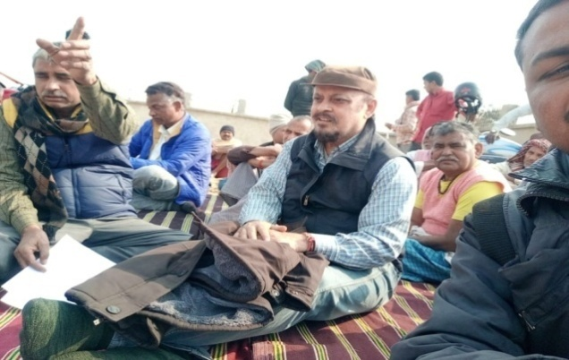
(Program Coordinator and Block Coord. meeting with Youths and ward members for program. briefing)
In due course it was decided to get cell number of all the community dwellers, or in other words every house hold. This data also shared with UNICEF Bihar for needful process.
Staffs orientation and experience sharing workshop
GSSG organized Staffs orientation and experience sharing workshopon23rd January2020 at Subh-yatra Guest house,Near Boring road Patna.All the Block Coordinators with Program Coordinator attended the event and shared their experiences in few minutes Mr. Rajeev Kumar, WASH Officer, UNICEF Bihar also attended and shared course of action and suggested to concentrate in one village and get contact number of every house hold and share the data in excel sheet for case study.
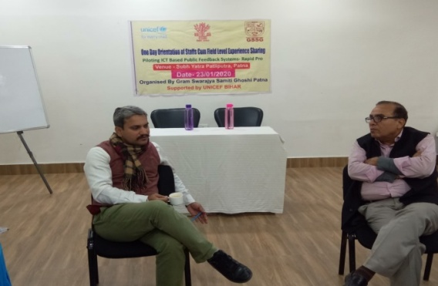
(Mr. Rajeev Kumar, WASH Officer, UNICEF, GSSG rapid Pro team during orientation cum sharing evet)
Mr. Rajeev Kumar, WASH Officer, UNICEF Bihar addressed the participants and shared that ICT based public feedback system is the technology adopted for getting public feedback on different WASH facilities as well as emerging development issues all over the world where there is presence of UNICEF and based on feedback, respective government of countries have taken initiative to curve down or in other words minimize the problem through initiating planned activities in eradication of menace.
The WASH officer also suggested Block Coordinators that keep collecting contact numbers of community and informed that triggering of next round will be conducted in the next month and if possible will be informed earlier to you.
Mr.Arunkumar, Program Coordinator also shared the journey of the Rapid Pro from beginning to till date and the shared the experiences through power point Presentation.
The WASH Officer, UNICEF Bihar also shared that triggering with small number of beneficiaries will be done in the end of this month .The program Coordinator ensured that numbers collected by the Block Coordinators will be shared soon. The cell numbers of villagers shared with UNICEF in due course.
Global Health Strategies
The program was focussed to create a conducive environment for improvement access to inform and expand contraceptive choices through the voices of credible CSOs,community champions and other key stake holders.
Key objective of the program was as follows:
- To create a pool of 20 community champions to be advocated for family planning.
- Strengthen linkages and advocate for family planning with government officials to address implementation challenges.
- Utilizing media platforms for dissemination of success stories and key community champion
Under this aegis organisation has performed different activities which are as follows:
- Sensitization on the family planning has been given to eligible group couple and IEC materials disseminated during the interaction meeting with beneficiaries and community members
- SasbahuSammelan
- Block level sensitization meeting has been given to the ASHA and ANM.
Case study:
Mr. Kaushlendra Pandey and his wife Ms. Kumari Mamta Sinha from Jehanabad district of Bihar have been supporting each other in generating awareness around family planning in their village. Mr. Pandey, a religious leader, was inspired by the work of, Brajkishore Tiwari, another religious leader, who disseminates family planning messages on occasions like weddings, festivals and others. Following his footsteps, Mr. Pandey also started talking about family planning and motivating newlywed couples to take an oath after the end of the seventh phera (The seven vows, known as Saptapadi, are performed, which is walking around the sacred fire. The Seven Vows along with the Seven Pheras are the most important ritual in a Hindu wedding as it sanctifies the union and affords social recognition to the marriage). The newly married couples are requested to pledge to opt for family planning methods after two children and maintain a gap of three years between the children. With his effort 9 couples have adopted different methods of family planning to delay the first child and space their children to ensure a small and healthy family. While the religious leader motivates people of his community to adopt family planning, Mamta Kumar, his wife (an ASHA) provides them the required contraceptives. So far, they have managed to motivate four women to adopt sterilization, six to use Antara injection and two couples pledged after their wedding ceremony to have a small family. Moreover, they are working with ANMs to provide more supplies of Antara in their village. By leveraging their existing rapport with the community members, providing people family planning information as well as helping them gain access to their desired contraceptive methods, the couple has gained popularity in their village. They are now commonly known as 'Parivar Niyojan Jodi' (family planning couple). Walking the talk, Ms. Sinha also underwent sterilization after their third child. Their story throws light on a unique aspect of this champions-strategy, wherein champions inspire others to become champions for family planning and work together by synergizing their efforts

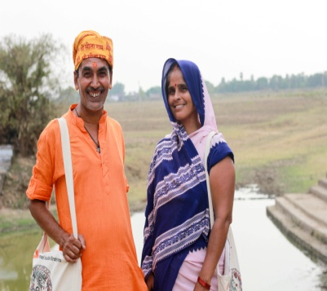
Family Planning Jodi

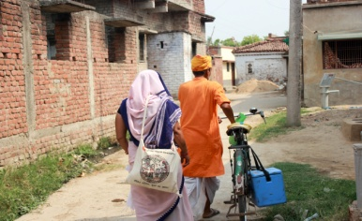

HamaraSwasthyaHamariAwaz Campaign

As per World Health Organization’s latest statement (June, 2016) one woman dies every five minutes in India from any cause related to pregnancy. Of the three million women who get pregnant every year in Bihar, 6,500 die from complications: haemorrhage (blood loss), infection, obstructed labour, hypertensive disorders and other underlying conditions that include anaemia. Along with Assam, Chhattisgarh, Jharkhand, Madhya Pradesh, Orissa, Rajasthan, Uttaranchal and Uttar Pradesh Bihar contributes to 67 % of maternal deaths in the country. Most of maternal deaths are preventable and violation of women’s right.
Maternal Mortality Ratio (MMR) in 2004-5, it was 312/lac which declined to 165 in 2014-16(Source- NitiAyog).The improvement may be attributed to positive changes in the health service delivery.

This campaign was initiated by Centre for Catalysing Change (C3) formerly known as CEDPA India, in partnership with Gram SwarajyaSamitiGhoshi (GSSG) in Bihar. Many women access public health facilities, health centres and hospitals for their reproductive and maternal health needs – such as pregnancy, childbirth, emergencies, contraception and family planning. It is the basic human right of every woman to good quality and affordable care. Through this campaign we have collected 1920women voices through the questionnaires and out of that 1920 women voices has been analysed on the base of facility which they were availing from the government PHC and local health centres in Jehanabad district.
The objective of HamaraSwasythaHamariAwaz campaign is to amplify women’s voices, their needs and priorities and present them to high level influencers.
Community Led Total Sanitation (CLTS)
Community Led Total Sanitation (CLTS) :Jharkhand’s critical water situation calls for large scale community engagement for operation and maintenance of hand pumps and water supply schemes. Therefore, as a strategy to strengthen the water supply scenario, World Vision entrusted the task of piloting community managed HP maintenance system through Community Empowerment. The expected role of Viswash Networking will be to encourage through capacity building and hand holding support to Mechanic of Hand Pump with community in Chas Block, Bokaro districts. Viswash Network will train the community as mechanics and caretakers to establish O & M system in place.
Operation and Maintenance (O&M) is critical for the sustainability of the water systems and yet is often neglected resulting in huge number of defunct water systems. This neglect or delay in applying proper operation and maintenance has adversely affected the credibility of the investments made, the functioning of the services and the well-being of rural populations. However, the importance of O&M has gained considerable visibility over the past few years, and it appears that policymakers are now more conscious of the direct links between improved O&M practices and the sustainability of water supply services.
The Overall purpose of developing groups on operation and maintenance of IM-II, IM-III and shallow well hand pumps in the state is to demonstrate a functional and replicable model of the community based O&M of drinking water supply sources through empowered mechanics so that PHED can internalize and institutionalize the process and can scale up the system across the state.
The implementation of O&M is not just a technical issue, but has social, community, gender, financial, institutional, political, managerial and environmental aspects as well.
The Training of Hand Pump Caretakers was conducted for a period of 3 days in this training 22 HP caretakers participated at Chas Block.

TRAINING OBJECTIVES:

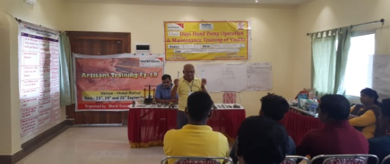

Objectives of the training:-
- Creation of trained man power for day to day hand pump operation and maintenance
- Develop as efficient hand pump caretakers
- Create a network of Hand pump caretakers and mechanics from the block level to the village level with tools for quick hand pump repair, operation and maintenance
- To re -orient the group of trainers on Hand pump repairing who at a later stage will Strengthen the process of improvement of water quantity and quality in project areas, and over cum upon the mistakes and keep the sources maintained.
- To continue the process for effective behavioral change of the Rural poor through its Community participation and improve service delivery project in adopting the safe way of use of drinking water at household level.

Neglected Tropical Disease( N T D )
The GSSG has taken up a very burning issue of Neglectedtropical disease (NTD)as it found that it has never been given attention at the community level.Lacs of people die due to negligible disease such asblack death(Plague), AES and recently erupted monster viral disease Corona is live example how it affect mankind in terms of morbidity, mortality and economic loss. As per one estimate due to Corona outbreak only Chinese economy is losing 30 Lakh Crore rupees worth.
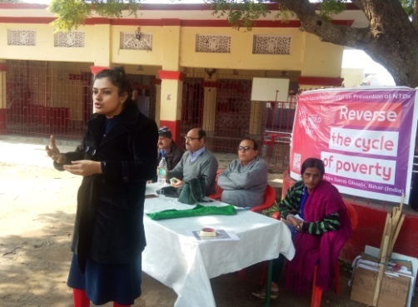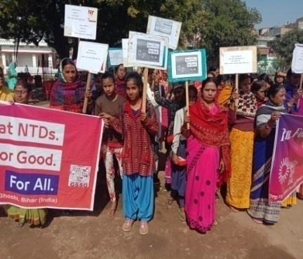
Community participated in “Run for NTDS”
PHC Dr.Sweta Sinha addressed the Community on NTDS

NTDs refer to represent a group of Chronic parasitic and related bacterial and viral infection spread in tropical and subtropical zones of earth. NTDs are mainly vector borne and the climatic condition becomes conducive to breeding and growth of such disease. NTD may be classified into various groups based on the mode and career of infection i.e. Parasitic (elephantiasis, sleeping sickness, river blindness, guinea worm) Bacterial (Trachoma, Buruli Ulcer, Leprosy); Viral (Dengue, Rabies, Japanese Encephalitis and latest entry of Korona virus); soil transmitted like hookworm disease, Trichuriasis, Ascariasis, Fungal (pityriasis vesicular, onychomycosis, tineacorporis, tineacruris, tineapedis). Disease like Trachoma causes blindness; Leprosy and Lymphatic filariasis causes deformation; Buruli Ulcer affect limb, rabies kills. The impact of NTDs is high in terms of losses of life and morbidity which ultimately affect economic and social wellbeing due to increased DALY indicators. It is found where there is low socio economic progress (like in Indian states like Bihar, Bengal, UP, Rajasthan) dues to which people are pressed to live in Substandard housing; poor availability of safe drinking water and sanitation facilities, filthy environment, abundant insect and other vectors contribute to efficient transfer of the diseases. NTDs disappear as living condition and hygiene improves. 2. Rationale of organizing World NTDs 2020 day in Bihar: NTDs are affecting lives of 1 billion people in world living mainly in rural area. On the occasion of world NTDs day 2020iented a community sensitization workshop was organized in Khagaul Nagar Parishad.Women of SHGs groups,youths, sanitation workers and sufferer of NTD were participated in this workshop. Total 95 persons were oriented through this workshop.
The programme was addressed by Dr. Sweta Sinha (Medical Officer –PHC Khagaul), Mr. Sunil kumar Sharma from GSSG assisted SWM Project, Bihar Dr. Bimal Kr.Jha: Reputed consultant-Government &Social sector advisory &Mr.Arunkumar from ICT based public feedback system rapid pro,UNICEF project served as key resource person for the programme.
After the training programme, a Public Run under the GSSG banner was organized in the chairmanship of Mr. Ram Shankar Sharma,Secretary, GSSG from Devisthan, Khagaul to chakardha more, khagaul.In the public run more than 150 local women, men, youth (boys and girls) actively participated and shared message of Neglected Tropical Diseases on play card. The objective of the run was to create awareness in the vicinity.
Paper clipping of the NTDs event:
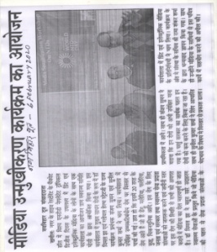 | 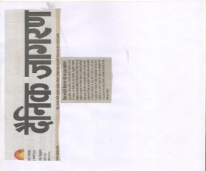

Paper Clippings:
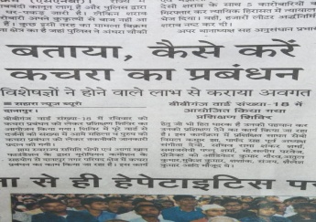 | 